OTFD – Setup a VM in Proxmox

1. Login to Proxmox
2. Expand out Pve, select local (PVE)

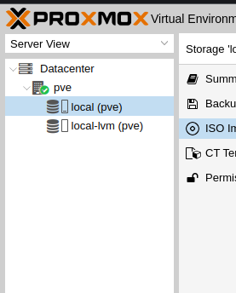

1. Click ISO Images

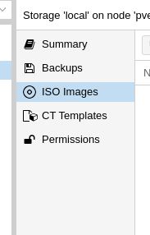

1. Click Upload

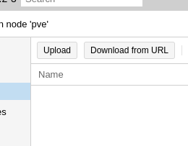

1. Select the file, set the name, and select any hash algorithm’s if available and click upload

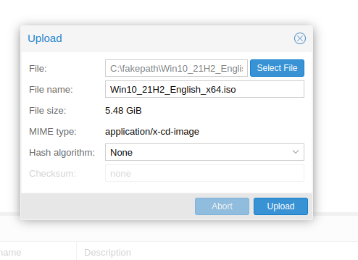

1. Wait for the task to finish

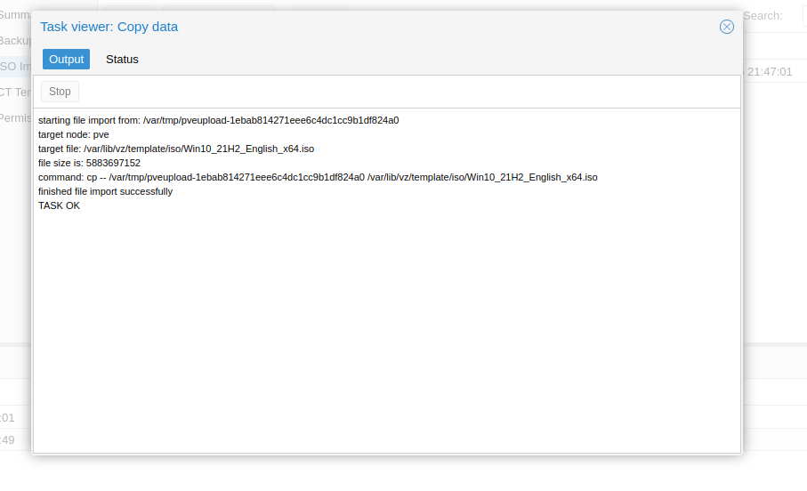

1. Click Create VM

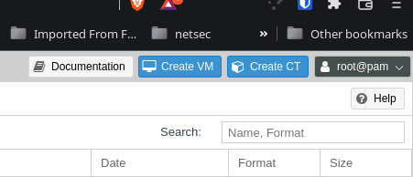

1. Set your Name on General tab,

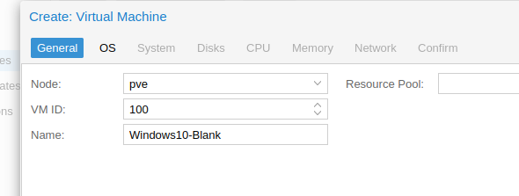

1. Setup the OS information under the OS Tab, select your ISO

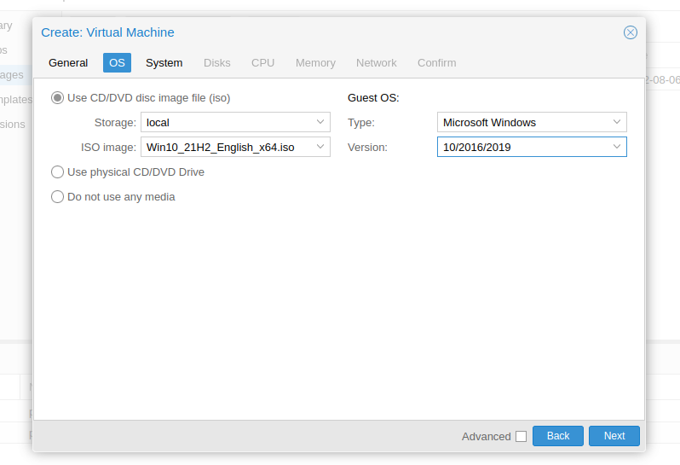

1. Setup any options under System Needed, click Disks



1. Set your disk Size, Device, etc,

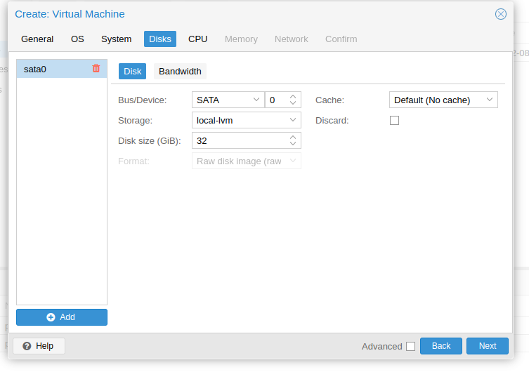

1. Set your sockets and cores

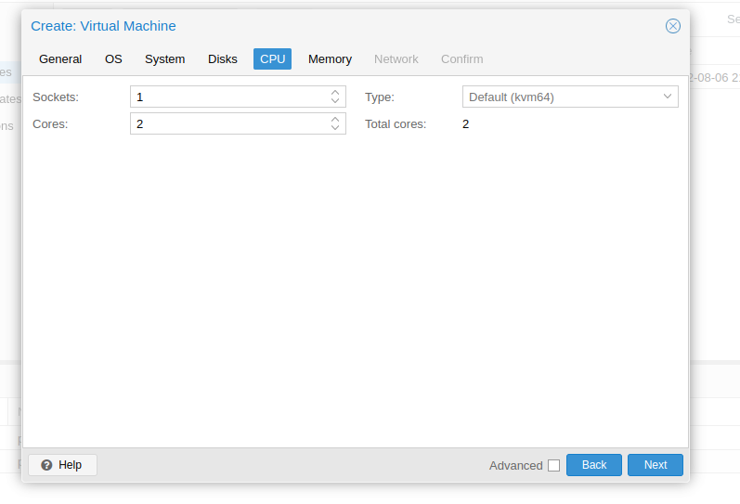

1. Set Ram

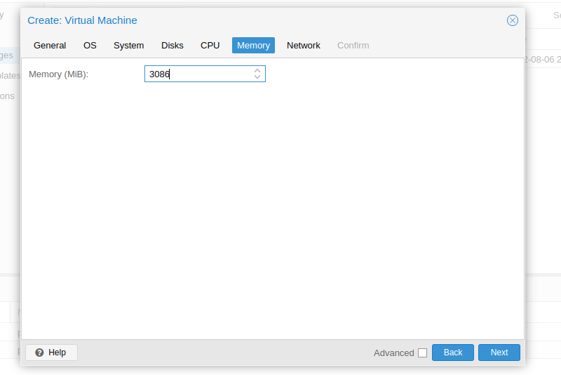

1. Set your network parameters



1. Confirm it all and click Finish
2. You can now start it, console into it, etc